SPH3U **Kinematics Unit Review**

1. A jogger runs 200.0 m [E], turns at an intersection, and continues for an additional displacement of 300.0 m [N]. What is the jogger’s total displacement?
2. Phrank has decided to take his dog Phido for a long walk. They start by walking eastward for $2.5 km$ and then northward for $3.75 km$. What is their displacement from the starting point?
3. Sylvie walks 7.0 km due north. She then turns and walks 5.0 km [E]. Finally she walks 3.0 km south. If the entire trip takes 3.5 h, what is her average speed and velocity for the trip?
4. Phil drove from Toronto to Oakville but he got lost along the way. He first went $30 km$ north, then $50 km$ west and then $10 km$ south and 5 km east. Find how far the two cities are apart by resolving Phil’s displacements and adding the components.

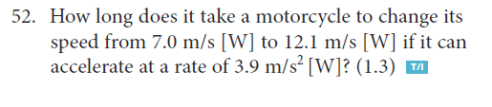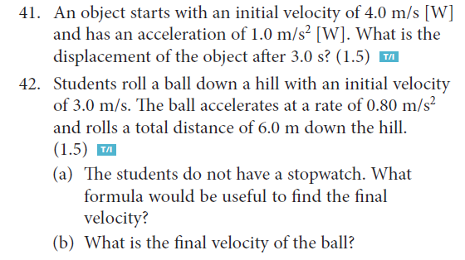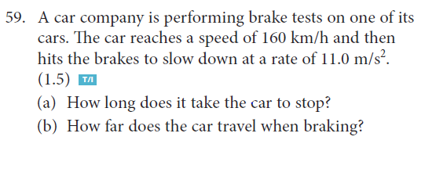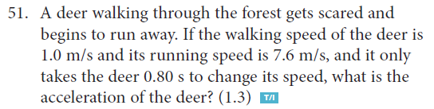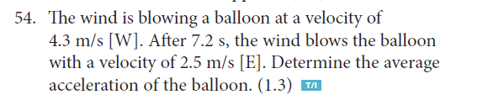

Ans: 1. 360 m [E56N], 2. 4.5 [E56N], 3. 1.8 km/h [N51E], 4.3 km/h 4. 49 km [N66W]

41. 17m[W], 42. 4.3m/s [down], 51. 8.3m/s2, 52. 1.3s, 54. 0.94m/s2, 59.(a) 4.0s, (b) 90m